ACCM
Bible Study: Thursday, November 16th, 2017. Topic: THE TIMES OF THE SIGNS II
TEXT: I Thess 5:1-9
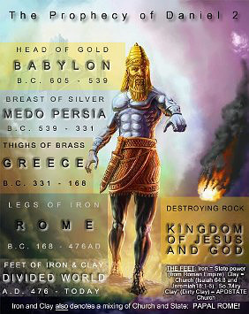http://www.signs-of-end-times.com/
INTRODUCTION: Two weeks ago, we ended the Bible study with the signs that are becoming evident now. We shall continue from there today. However, if you are an end time student, you would have heard about the pre-millennial and the post millennial reign of Christ. Pre-millennial being focused on the rapture before the coming of Christ and post-millennial talks about the rapture after the second the coming of Christ. Most of the signs we shall be talking about here will be for either before the rapture or after the rapture. Someone will say what is the difference? The diffefrence is that if you want to be specific on certain signs, you will find out that they will only happen at certain times. A clear example you will find in Matthew 24: 15 (Daniel 9:27). At this time beloved, my desire for me and you is that we will not be here when these shall start to happen. The statement in verse 3 of the scripture we read is sounds more like a post millennial.sign however things are aligning themselves today to make that come to pass. Paul said ‘and when they’ as compared the words ‘we’ which he used in I Thess 4:15 and 17.
The sign of the return of Jesus are discernable, even if the moments of His arrival is not predictable (Bible Knowledge commentary). To the believers that have adequate knowledge, the signs of his second coming should be discernable. Matthew 24:32-34
This day will come as a thief: Matthew 24:43-44. But not for the believers. I Thess 5:4-7
WHAT ARE SOME OTHER SIGNS OF THE TIME?
- The state of the church today II Tim 3:1-9. Hidden in this scripture is the problem of the church today.
- The drive for peace. I Thess :5:3
- The mark of the beast and the ability to enforce it. Rev 13:16-17. With the advent of the cashless society, the biometric data, the modern-day access control where we do not need cards any longer etc. are emanating technologies that will make the anti-Christ very functional.
- Nonchalance to the gospel: Matthew 24:37-39.
- Violence: Gen 6:13 The days of Noah was characterized by violence.
CONCLUSION: Others might not see it coming or they might have been believed that what we are doing are gimmicks to deceive people. However this should not be your case. For many who criticize the believers, my answer to them has always been what is their problem if we choose to live the life we want to live.

